AstroCell

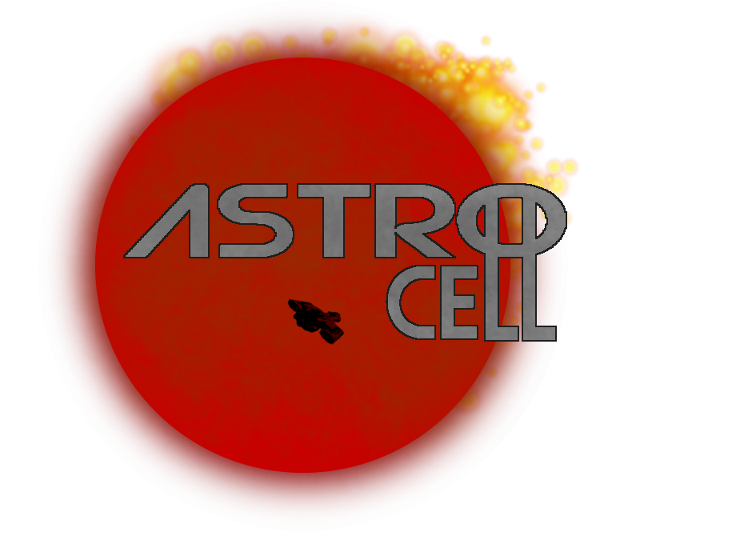

**Space_Turtle**

Designer: Ryan Black

Document Creation Date: 10/18/2020

**Level Finish Date: <DATE>**

Version: 1.0

Last Update Date: 10/19/2020

**Table of Contents**

**Level Layouts**

**Layout Elements Key**

**Gameplay**

**Game Narrative (Leading up to this Level)**

**Level Objectives**

**Level Narrative & Walkthrough**

**Mechanics Required to Complete Level**

**Previous to this Level**

**Learned in this level**

**Special Features**

**Look and Feel**

**General**

**Genera**

**Mood**

**Pacing**

**Environment** *(Each Unique Section requires the following)*

**Architecture**

**Materials**

**Color Composition**

**Lighting**

**Initial Visual Impacts**

**Music \ Sound \ Dialogue**

**Level Music**

**Sound and Music Inspirations**

**Ambient Sounds**

**Specific Sounds**

**Dialogue \ Voice Over**

**Asset Lists**

**Packages \ Sets**

**Unique Level Elements**

**Other Level elements**

**List of Elements Needed**

**Level Layouts**

Space_Turtle is a vertical map centered around a hub area and branching off into the different task rooms. On the upper level is the rooms for the warden and guards, where the prisoners are not allowed. The brig is the central area, where the prisoners start the game, then branches out into the individual task rooms. Above all of the map is the Guards only section, which can be accessed by a set of stairs near the brig.

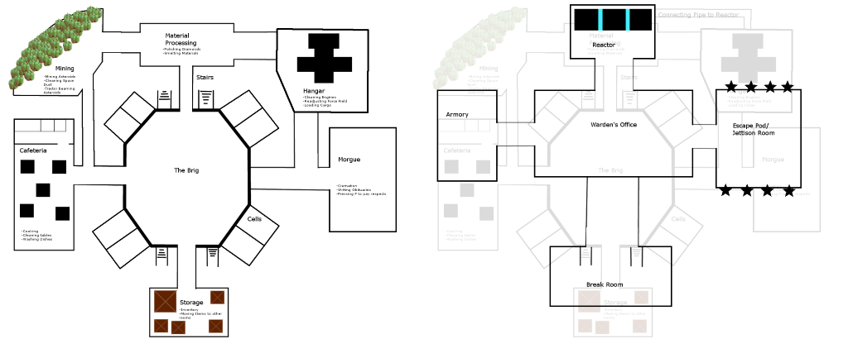

**Gameplay**

**Game Narrative**

Dark Star Penitentiary is one of many prison barges funded by the IPA (Intergalactic Planetary Alliance), who keeps the worst of the worst on prisons built into large planetoids that harvest asteroids for valuable materials. The barge has a reputation for being inescapable. Once you get off the station, the only place left to go is the planet below, a molten hellscape barraged by meteor showers. However, the enigmatic warden, one of the few humans who run the IPA Prison complex, has decided to make his visit known, flying his personal shuttle over to the station. With the opportunity presenting itself, the prisoners plan a grand escape. They have many options, but the last day before their execution, the prisoners make their decision on how they plan to leave...

**Level Objective**

**Guards:** Keep the prisoners under control long enough for the day to pass and the prisoners to be executed.

**Prisoners:** Find the parts they need to escape, then escape

**Level Narrative & Walkthrough**

The map is a hub and spoke style map all centralized around the Brig, a massive Octagon where the prisoners start in their cells. Connected to several of the sides of the brig are the cells, where the prisoners are sent to if they are caught. Branching off from the brig are the many rooms where tasks are located. The Cafeteria is where the prisoners have tasks such as Cooking, cleaning, and sorting through food. The Mining room is where asteroids are brought in for mining, where prisoners will do tasks such as tractor beaming in asteroids and ejecting anything unvaluable. Material processing is where the valuables from the mining room are processed. The hangar is where cargo ships (Or in special instances, the Warden’s shuttle) enter and exit. The morgue is where dead prisoners are cremated and eventually sent to the Jettison Room. Finally, the storage room is where prisoners can find objects and move them around to other points of the map. Above the brig and all previous rooms is the Security Level. Only the guards and warden are supposed to go up there, but a prisoner can find their way up there if they try. The Warden’s office hangs over the Brig and is where the Warden usually hangs out. Behind it is the reactor, which powers the station and can be sabotaged to disable components or potentially nuke the station. The Break room is where the guards hang out, and has a few amenities that may be useful for the prisoners. The Escape Pod/Jettison Room is where the guards would go if the station were to be under siege or in danger of exploding. It’s also where they eject useless cargo, such as Dented diamonds, asteroids that can’t be sold, dead people ashes, etc. The Armory is where the guards can get armed, and where they go to get updated should their AI malfunction.

**Mechanics Required to Complete the Level**

Most of the basic gameplay mechanics are used throughout the level, but some tasks are geared towards the map in specific ways. This is the case for all levels in AstroCell

**Look and Feel**

**General**

Dark Star Penitentiary is not a very nice place, and this is blatantly obvious by the way the map looks. The prison portion of the map is cold, dirty, and not well maintained. Parts of the station are broken, televisions that are in prisoner cells show only static, and a fair number of machines are straight up broken. This can be used to the prisoner’s advantage though, as some of the broken machinery can be broken into to salvage spare parts. On the other hand, the Guards only section of the map is luxurious, with leather chairs, velvet floors, and an arcade machine. The life of a guard is a comfortable one, but one that could easily make them complacent.

**Genera**

Space_Turtle has a very heavy gritty Sci-Fi feel, or at least as much as the art style will allow it.

**Mood**

Space_Turtle’s mood has a shade of darkness to it, but in a comedic way. Things like the morgue having a pipe that leads directly to the Jettison room, implying that they jettison the corpses as soon as everyone is done with the mourning is bleak, but humorous at the same time. The Storage room is filled with everything on both sides of the comedic-dark spectrum. From Portable Head Exploders to Construction Permits to Smooth Brain-inators, the contrast is dark enough that it can turn around into being funny.

**Environment** *(Each Unique Section requires the following)*

**THE BRIG**

**Architecture**

The brig has a heavy focus on an industrial feel. The cells are the most maintained thing in the prison, and each cell has their own personalization (Maybe even a customization feature?) to stand out, like one cell having a broken toilet or one cell having a poster of a girl from an old-world movie. The central focus is on the center of the brig, which has a grate that allows you to look below the brig to the many cells below.

**Materials**

Concrete, Metal (Iron), cotton for beds, and plastic, paper, and whatever is appropriate for the personalized objects.

**Color Composition**

Heavy focus on greys, but with sharp moments of Orange and a bit of silver

**Lighting**

Pretty dull, mostly industrial lighting, nothing too fancy.

**Initial Visual Impacts**

The sight of the other prisoners in the brig, plus potentially the many cells blow.

**HALLWAYS**

**Architecture**

The hallways carry over the theming of the brig, but with a connecting theme of each of the other sections of the map carrying through the halls. For example, the connection to the showers will feature a spill in front of the entrance, while the entrance to the food court will see some spilled food on the floor. On the walls are colored arrows that lead to the different parts of the station.

**Materials**

Concrete and metal, with various materials for the connecting rooms, and paint on the walls for arrows

**Color Composition**

Lots of whites, with some colors for arrows to different parts of the ship.

**Lighting**

Pretty dull, mostly industrial lighting, nothing too fancy, like the brig.

**Initial Visual Impacts**

The stark colors of the arrows that lead you to the different sections of the ship.

**CAFETERIA**

**Architecture**

The cafeteria is split into two seconds. The first is the dining area, where large tables take up a majority of the area. The second is the kitchen, where various cooking implements are strewn about, with various unfinished meals strewn about. Various machines are placed about, including the Soda Fountain

**Materials**

Whatever material they use to make school tables. Various “Food” materials

**Color Composition**

Whites and greys with flashes of color from strewn about food

**Lighting**

Well lit, with a lot of focus on the tables in cafeteria.

**Initial Visual Impacts**

The large tables and the mess of food thrown about.

**Music \ Sound \ Dialogue**

**Level Music**

Any music that would be on the station would be Diegetic. The hum of workers digging through asteroids, broken TVs playing motivational music, classical vinyl in the Warden’s Office. Everything in the map has a source to it, and it makes the prison seem larger than the playable area. The Music itself should not be overbearing, just loud enough to be known.

**Sound and Music Inspirations**

* Chain Gang Music (Mining/Material Processing)
* Synth (Most of the map)
* Classical Vinyl (Warden’s Office)

**Ambient Sounds**

Most sounds are ambient sounds, but the footsteps and rotating motors of the wheels should be loud enough to punctuate the atmosphere, to know that someone is nearby.

**Specific Sounds**

Whenever a voice comes over the intercom, a loud and noticeable tone is played.

Certain tasks have a notable sound attached to them (Drilling has a whirring noise, Cooking will have a sizzling sound, etc)